**Course 5-See who is pressing fast**

****Learning goals:****

In this lesson, we will make a very simple micro:bit game. When we press the A button, the micro:bit dot matrix will display an arrow pointing to the A button; when we press the B button, the micro:bit will display an arrow pointing to the B button; if no button is pressed, the micro:bit It shows a heart.

**Code：**

from microbit import *

while True:

if button_a.is_pressed():

display.show(Image.ARROW_W)

elif button_b.is_pressed():

display.show(Image.ARROW_E)

else:

display.show(Image. HEART)

display.clear()

**Programming and downloading：**

1. You should open the Mu software, and enter the code in the edit window, , as shown in Figure 5-1.

**Note! All English and symbols should be entered in English, and the last line must be a space.**

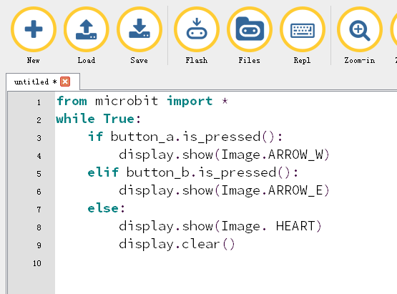

Figure 5-1

2.As shown in Figure 5-2, you need to click the Check button to check if our code has an error. If a line appears with a cursor or an underscore, the program indicating this line is wrong.

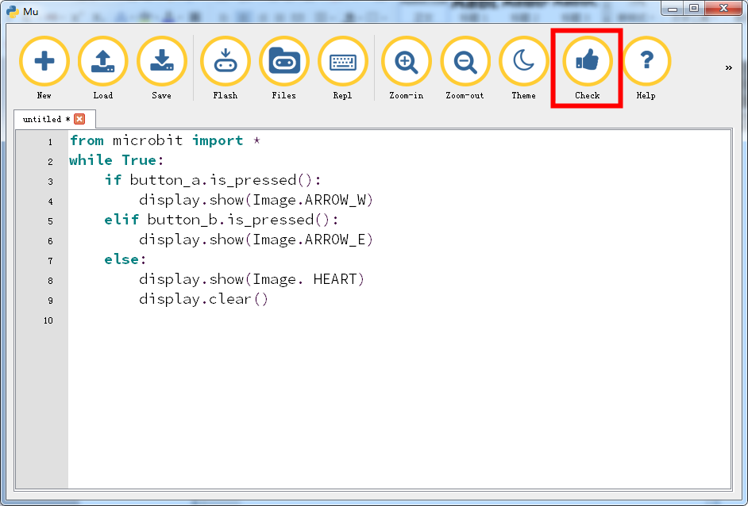

Figure 5-2

3.You need to connect the micro data cable to micro:bit and the computer, then click the Flash button to download the program to micro:bit as shown in Figure 5-3.

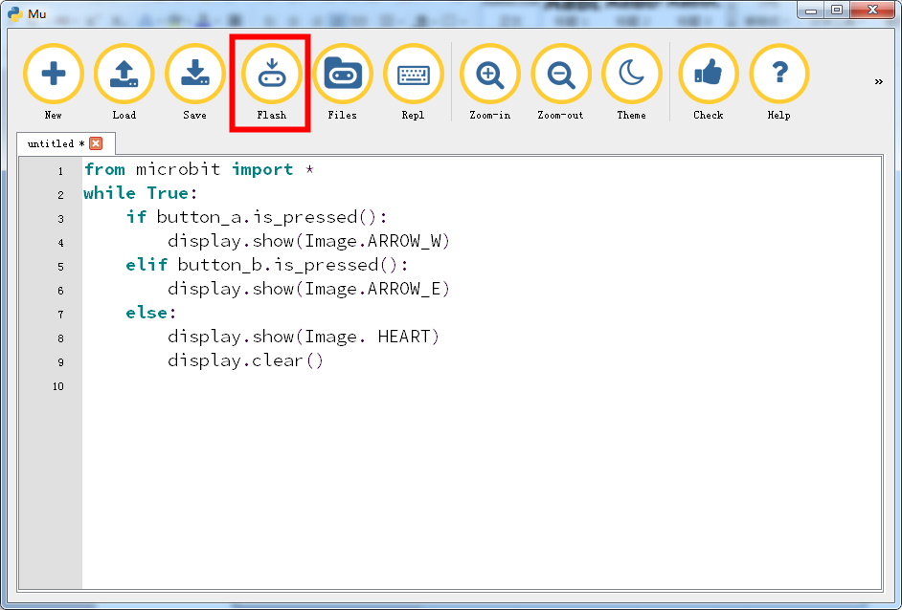

Figure 5-3

4.After the download is successful, we can see that the micro:bit shows a heart,as shown in Figure 5-4.When we press the A button, the micro:bit dot matrix will display an arrow pointing to the A button, as shown in Figure 5-5; when we press the B button, the micro:bit will display an arrow pointing to the B button,as shown in Figure 5-6.

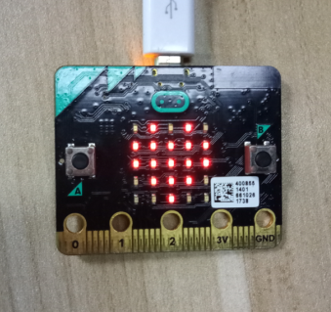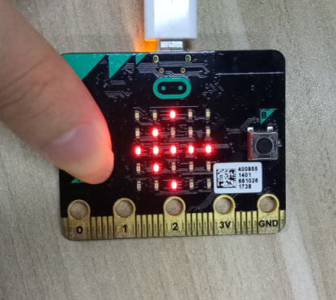

Figure 5-4 Figure 5-5

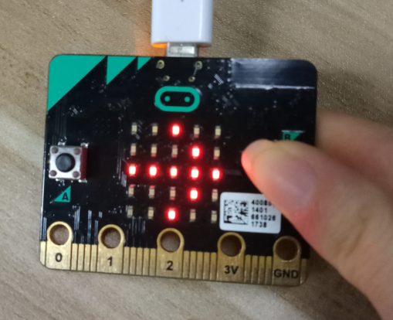

Figure 5-6